Sort 4 Spelling Words
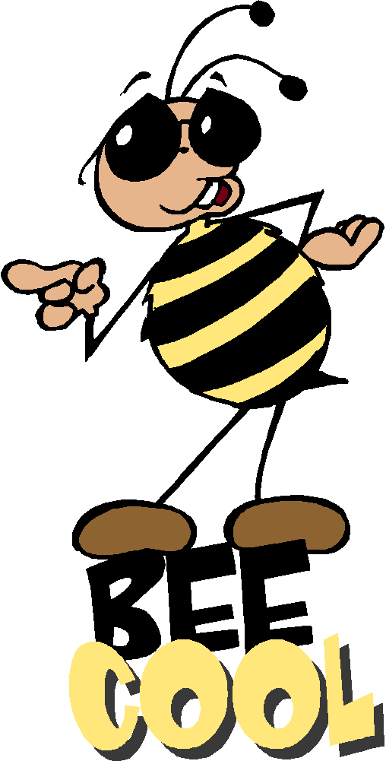
Short and Long Vowel i

slide smile dive write bike
kite chin zip hill crib
pig twins

Spelling Test Friday on ten of your weekly spelling words, remember to study every night.

Sort 4 Spelling Words
Short and Long Vowel i

slide smile dive write bike
kite chin zip hill crib
pig twins

Spelling Test Friday on ten of your weekly spelling words, remember to study every night.

Sort 4 Spelling Words
Short and Long Vowel i

slide smile dive write bike
kite chin zip hill crib
pig twins

Spelling Test Friday on ten of your weekly spelling words, remember to study every night.

